**Q1 write a program to count_letter(word,letter) returnsno of occurrence of the letter in word ?**

**Code:**

def count_letter(word,letter):

count=0

for i in range(len(word)):

if letter==word[i]:

count=count+1

return count

word=input("Enter the word :")

letter=input("enter the letter:")

count=count_letter(word,letter)

print(letter,"word is replated:",count,"times")

**output:**

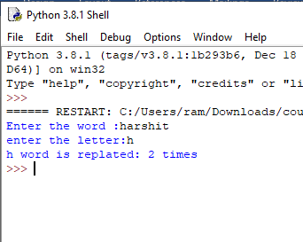

**Q2 write a program to check list is palindrome or not no if list palindrome then return True else False?**

**Code :**

def pal(lst):

k=lst[::-1]

if k==lst:

return True

else:

return False

lst=[]

print("enter the list size")

n=eval(input())

for i in range(n):

l=(input("enter the element of list :"))

lst.append(l)

c=pal(lst)

print(c)

print(lst)

**output:**

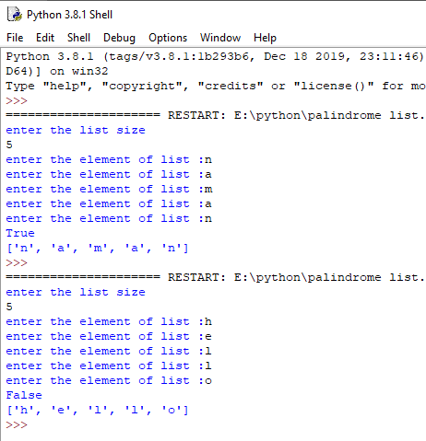

**Q3 write a program that prompts a user to enter of list and add the element to the list write a function maximum(list) and minimum(list) to find max and min no from list ?**

**Code:**

def maxfunction(lst):

min=lst[0]

max=lst[0]

for i in range(len(lst)):

if(max<lst[i]):

max=lst[i]

return max;

def minfunction(lst):

min=lst[0]

for i in range(len(lst)):

if(min>lst[i]):

min=lst[i]

return min;

lst=[]

print("enter the size of list")

n=eval(input())

for i in range(n):

k=eval(input())

lst.append(k)

ret=maxfunction(lst)

ret1=minfunction(lst)

print("max value :",ret)

print("min value :",ret1)

**output:**

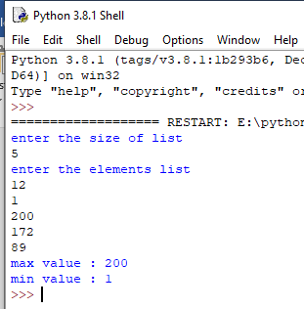

**Q4 write a program to count the frequency of characters using get methods?**

**Code:**

def fun(a):

d={}

for i in a:

if i not in d:

d[i]=1

else:

d[i]=d.get(i,0) +1

print(d)

a=input()

fun(a)

**output:**

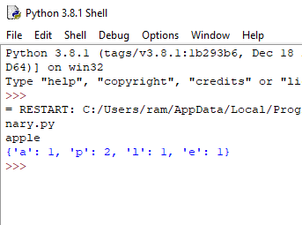

**Q5 write a program to store square of numbers into dictionary ?**

Code:

def fun(n):

d={}

for i in range(n):

d[i]=i*i

print(d)

print("enter the size of dictionary :")

n=eval(input())

fun(n)

**output:**

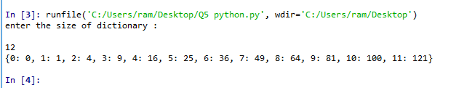

**Q6 write a program to convert octal into binary using dictionary?**

**Code:**

d={"0":"000","1":"001","2":"010","3":"011","4":"100","5":"101","6":"110","7":"111"}

def fun(value):

print(value,"binary value :")

for i in range(0,len(value)):

f=value[i]

print(d[f],end="")

value=input()

fun(value)

**output:**

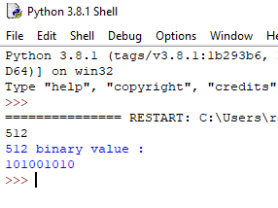

**Q8 writa a program to sort the element of list in ascending and descending order?**

**Code:**

**Ascending:**

d={'d':65,'a':35,'c':1,'b':79}

for i in sorted(d.keys()):

print(i,d[i])

**output**

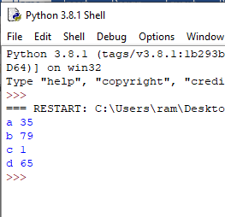

**Descending:**

d={'d':65,'a':35,'c':1,'b':79}

for i in sorted(d.keys(),reverse=True):

print(i,d[i])

**output:**

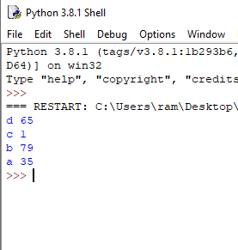

**Q write a program to sort the list using insertion sort?**

**Code:**

z=eval(input("enter the size of list:"))

print("enter the elements in list :")

lst=[]

temp=0

for i in range(0,z):

e=eval(input())

lst.append(e);

for i in range(0,z-1):

min=i

for j in range(i+1,z):

if(lst[j]<lst[min]):

min=j

temp=lst[min];

lst[min]=lst[i];

lst[i]=temp;

print("sorted list :")

print(lst)

**output:**

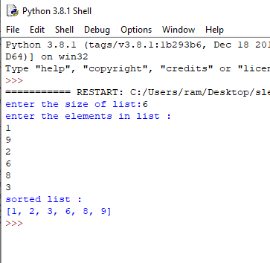

**Q10 write a program to remove the vowel from string ?**

**Code:**

def fun(n):

d=list(n)

for i in d:

if i=='a':

d.remove(i)

elif i=='e':

d.remove(i)

elif i=='i':

d.remove(i)

elif i=='o':

d.remove(i)

elif i=='u':

d.remove(i)

str1=""

for i in range (len(d)):

str1=str1+d[i]

n=str1

print(n)

value=str(input())

fun(value)

**Output:**

